Colosseum Level Design Document

Contents

High Level Design Overview 2

Main Objectives 2

Design Motivations 2

Key Elements 2

Expected Player Experience 3

Overview Map 3

Points of Interest 3

Aesthetic (Look and Feel) 4

Pickups 7

Pathway Maps 9

Conflict Points 9

Choke points 10

Balance Considerations 12

Expected Issues 12

Testing Plan 13

Mitigation Strategy 19

# High Level Design Overview

## Main Objectives

Main objectives are to build a king of the hill map that is inspired by roman colosseum. The map should resemble a colosseum.

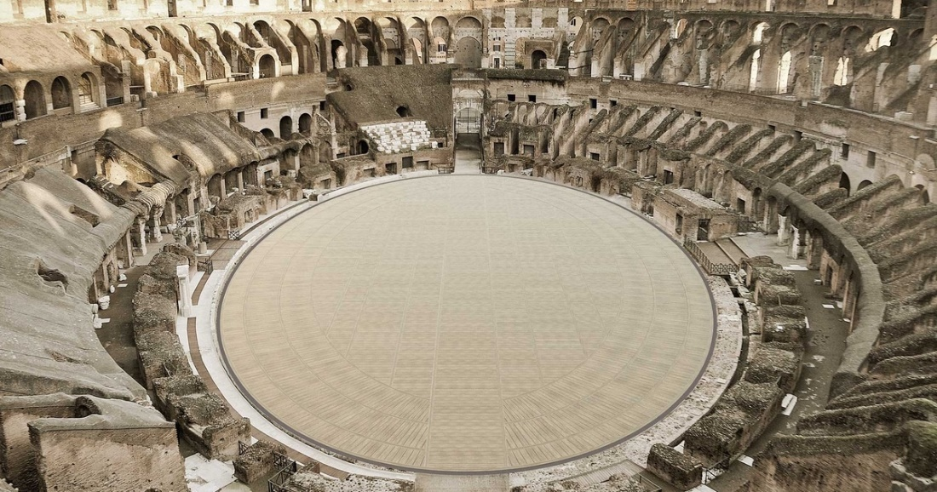

## Design Motivations

Design motivations for this map is the roman colosseum. The arena style will have to look and be laid out like a colosseum, where the emperor has the best view and there would be minimal cover to promote an aggressive playstyle.

## Key Elements

The key element of the map is the emperor’s box. This is the main point of interest as this point gives the player an advantage of position over the other team.

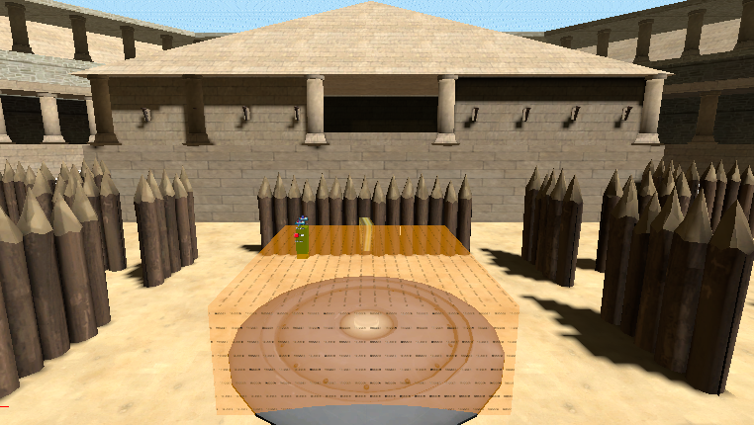

## Expected Player Experience

Casual Players: casuals would feel more at ease with map as it is easy to flank the enemy team in the map.

Competitive Players: Competitive players will be more pressurized as emperors box plays a huge role in which team is winning the round.

# Overview Map

## Point of Interest

The main point of interest for this map is the emperor’s box. This point will have a bird’s eye view of the map. Any player standing in the emperor’s box will also be visible to all enemies. The player will have to walk up to the edge of the view zone to take any shots towards the player on the ground.

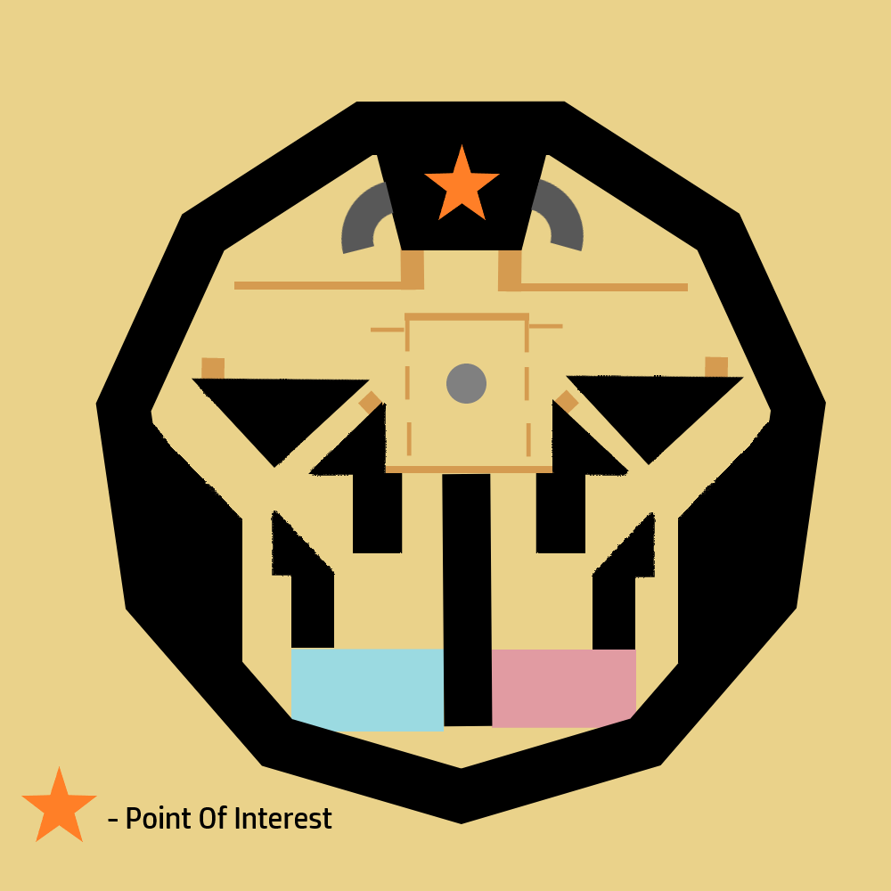

## Aesthetic (Look and Feel)

The map is inspired by the roman colosseum, the look of the map will match that of real colosseums built. There will be minimal meshing as from research done on colosseums, there were not much placed in the arena.

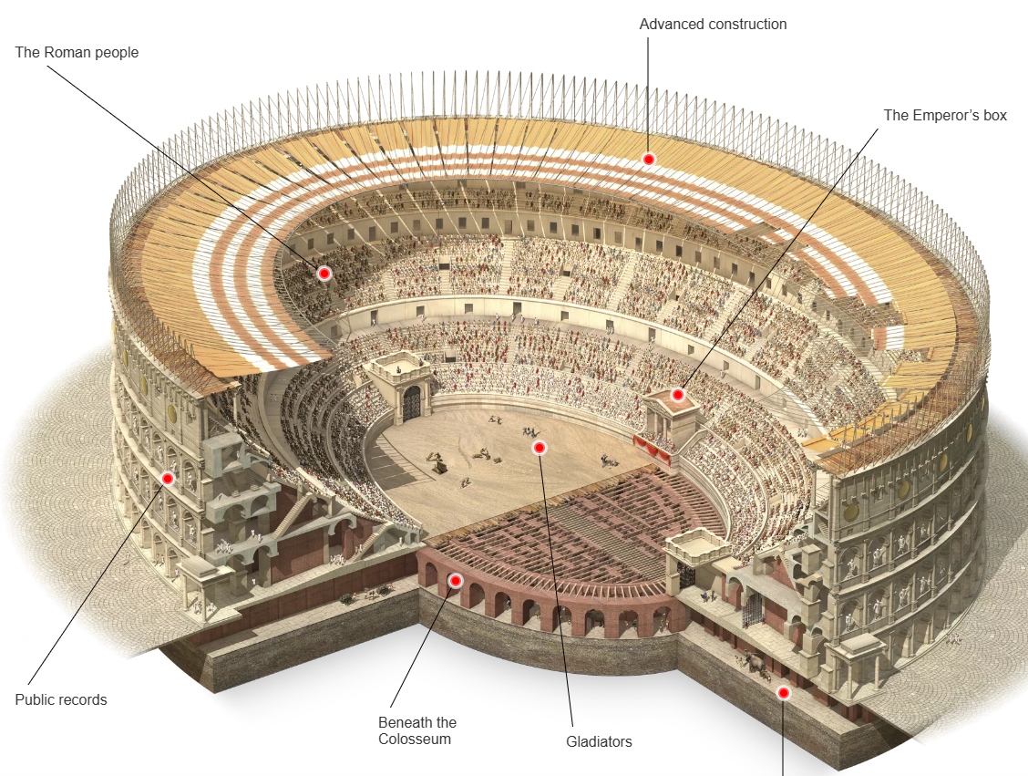

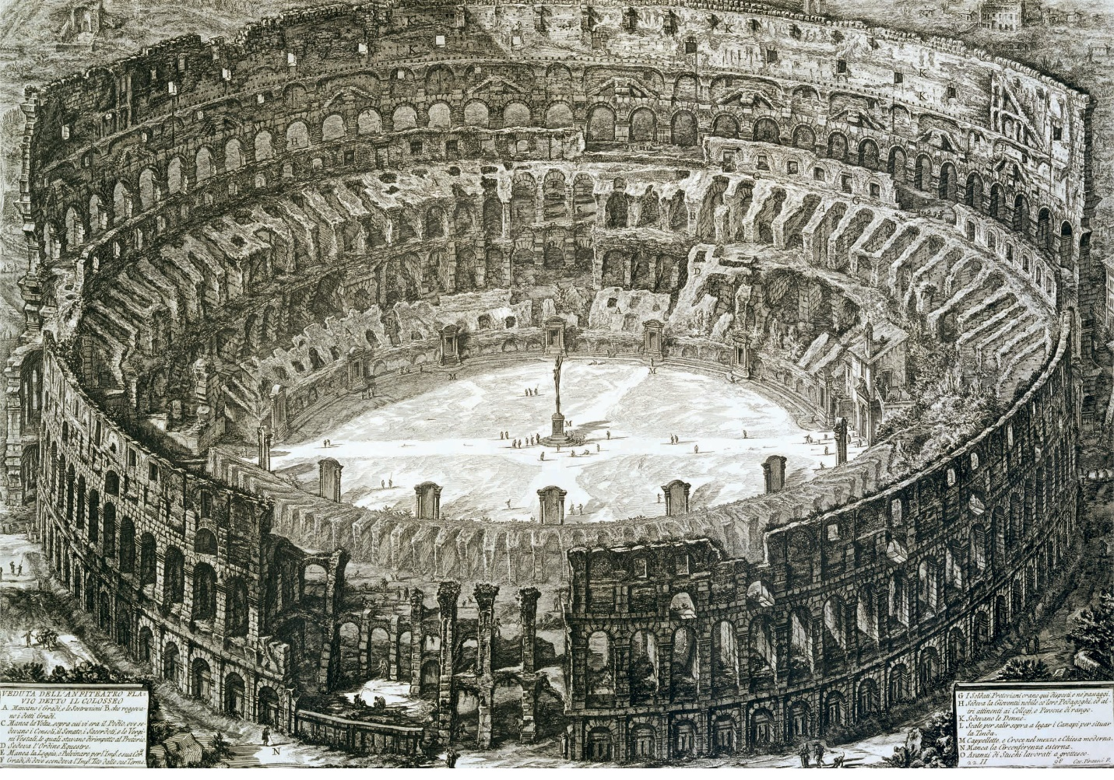

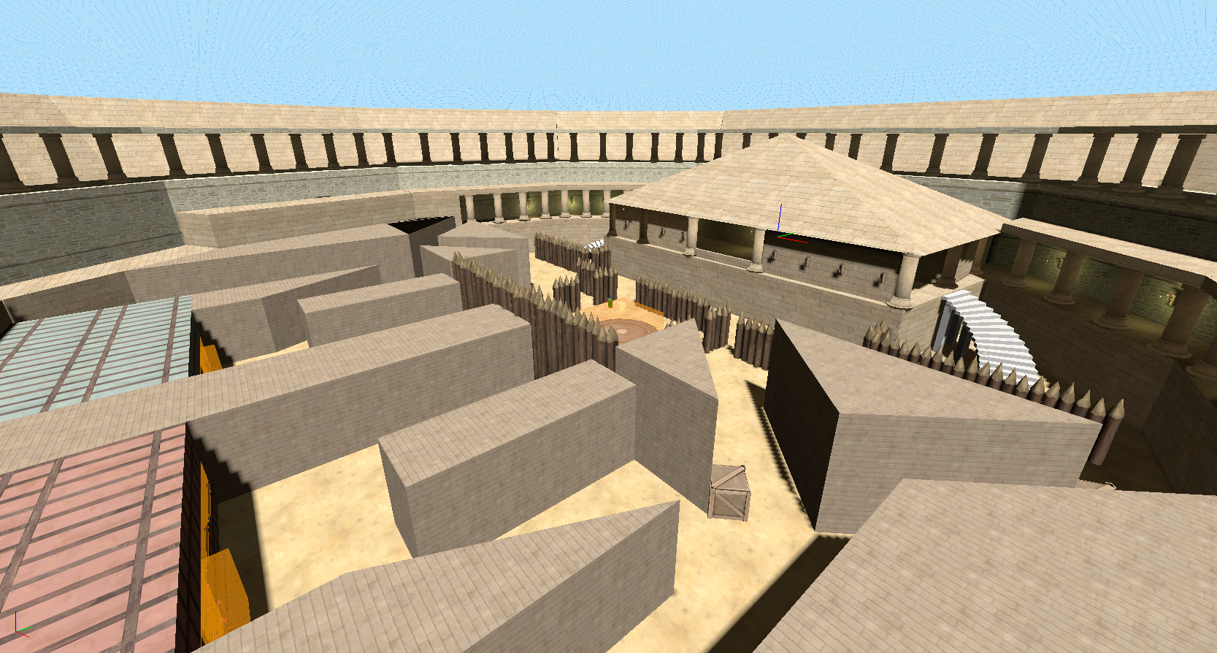

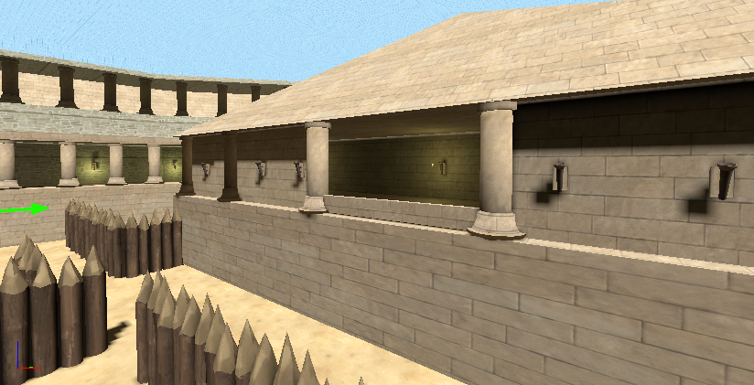

## Pickups

The pickups present for this map are HP and Ammo Pickups. There are more HP pickups present on the map due to the amount of cover present in the map. Ammo is only located at two points on the map, this is to increase the aggressive nature of the map for the players.

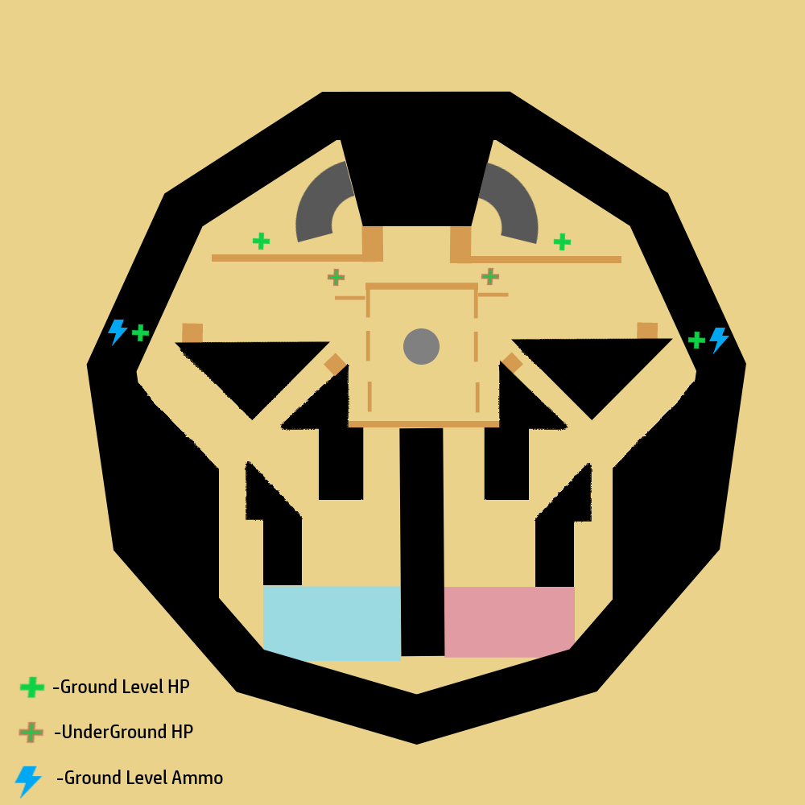

HP and Ammo Pickups in the Map

# Pathway Maps

## Conflict Points

These are the conflict points present on the map. There are three located within the map. The ones on ground level are at the control point where the players will meet and the other is at the emperor's box as it is built like a corridor. The third is in the underground section of the map. In this area, there is an opening to promote flanking. Therefore, the underground section can be contested.

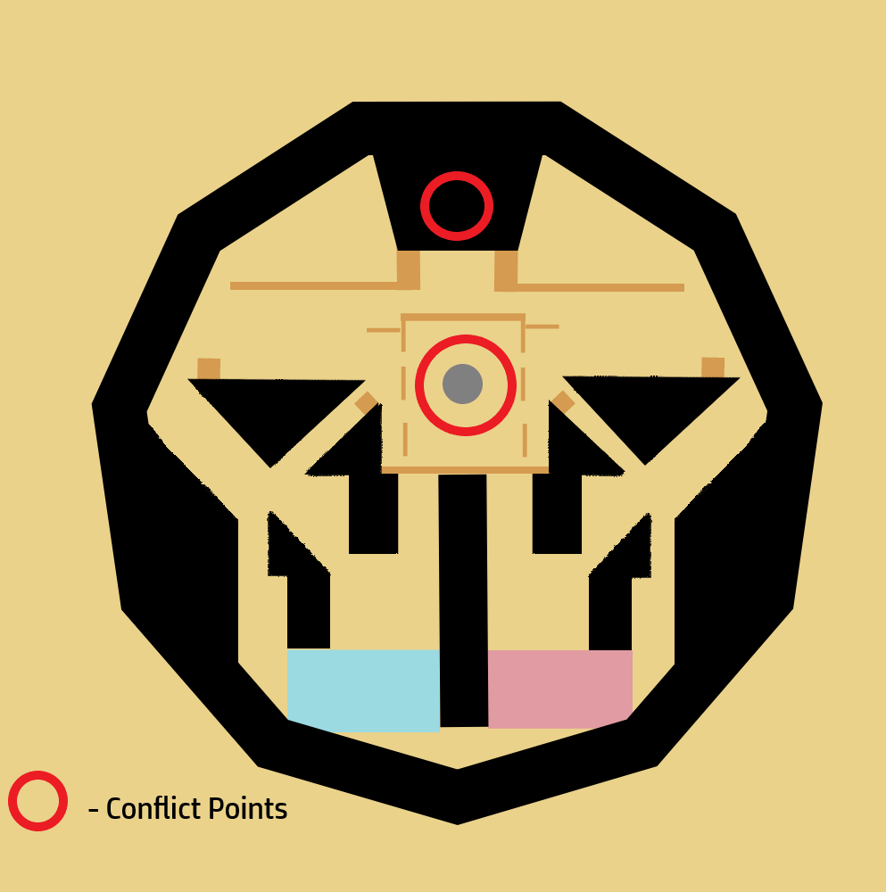

Conflicts Ground Level

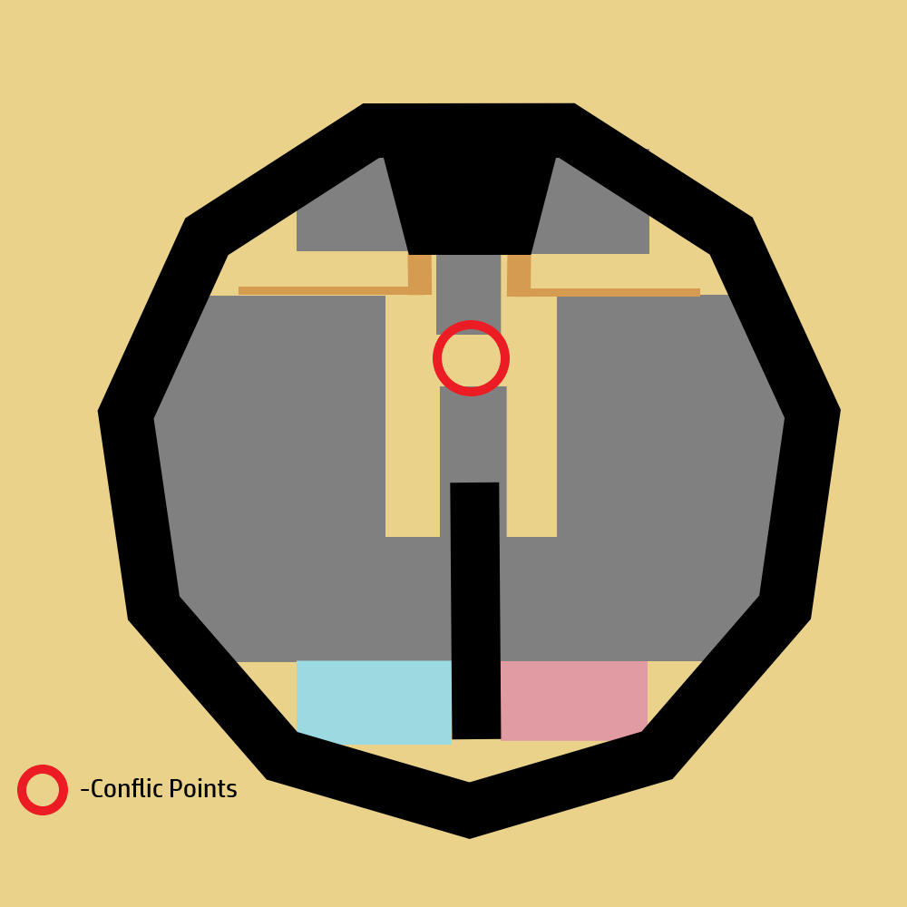

Conflicts Below Ground Level

## Choke points

The choke points highlighted below are the locations where the if the player decides to counterattack near spawn or the flank routes. This can be contested easily.

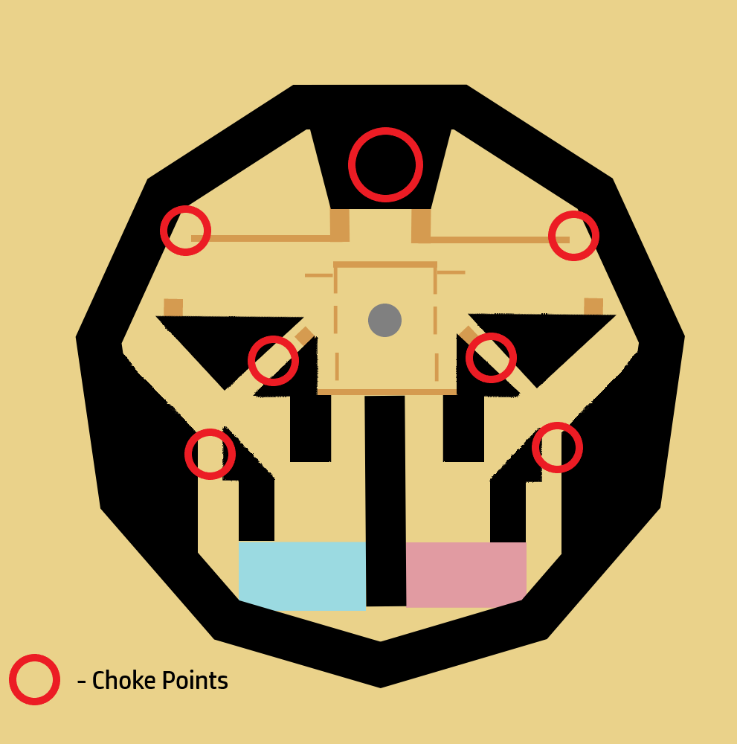

Choke Point Ground level

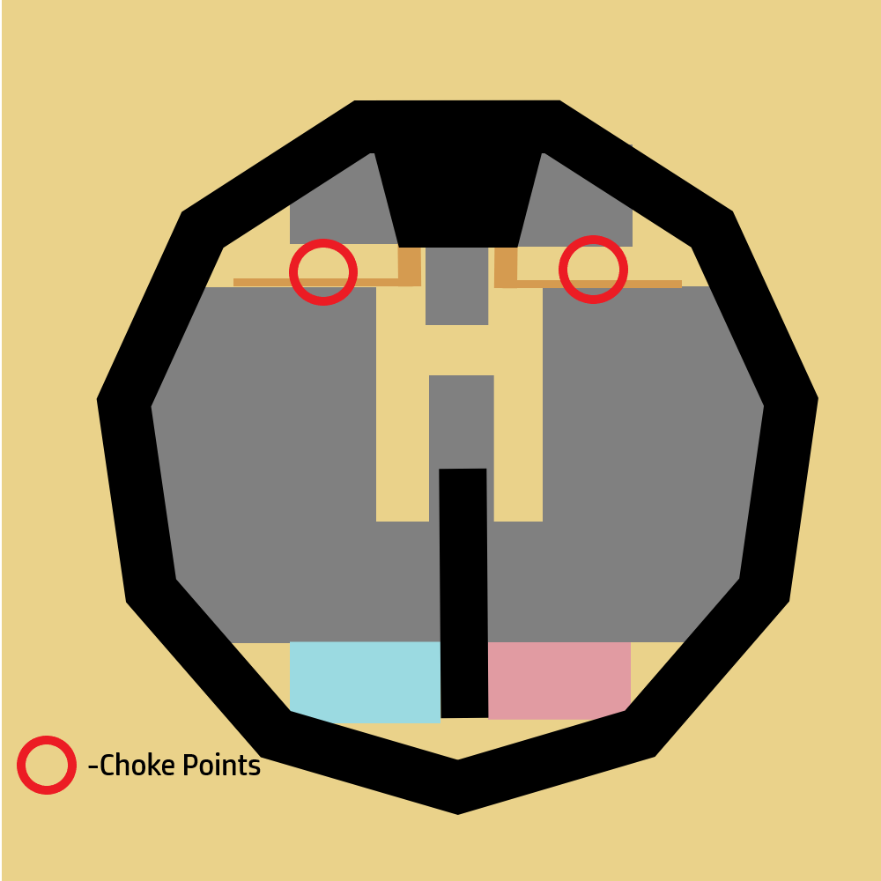

Choke Point Below Ground

# Balance Considerations

## Expected Issues

The first issue would be getting used to hammer engine. This would be my first time using the engine. There would be an issue with having an advantage being in the emperor’s box. This would give the player a better view of enemies and it is also harder to shoot a target above ground.

## Testing Plan

I would conduct play-testing sessions within the game and in-person testing sessions of the map. It would question the player on why they took certain routes on the map, about cover placement, the point of interest. I will be testing with friends. Having them run through the map and play a couple rounds.

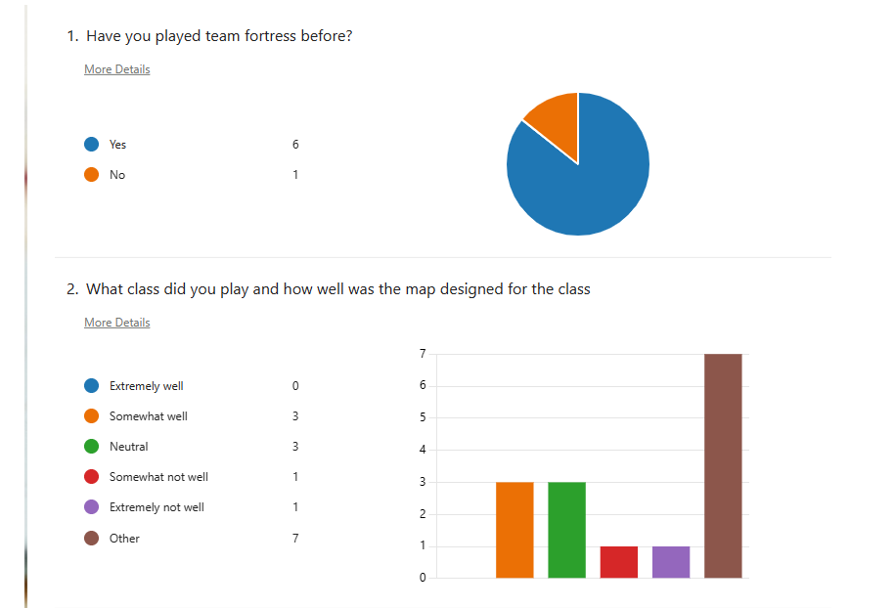

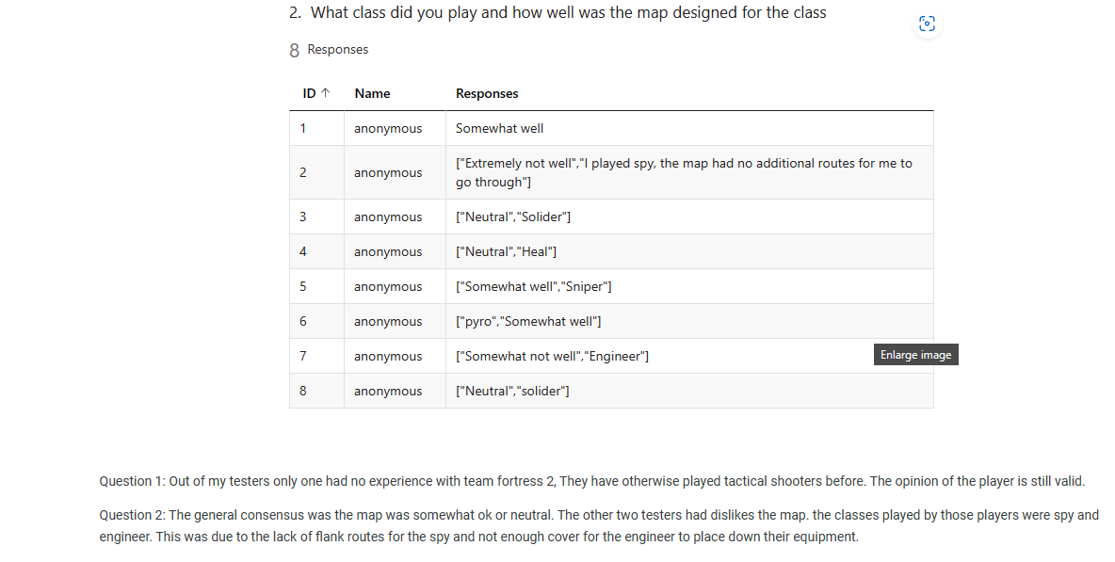

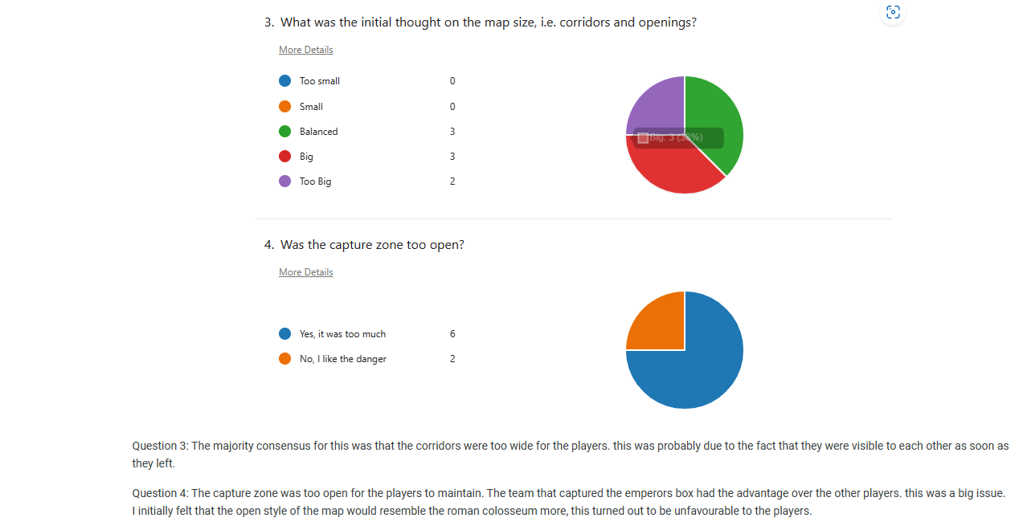

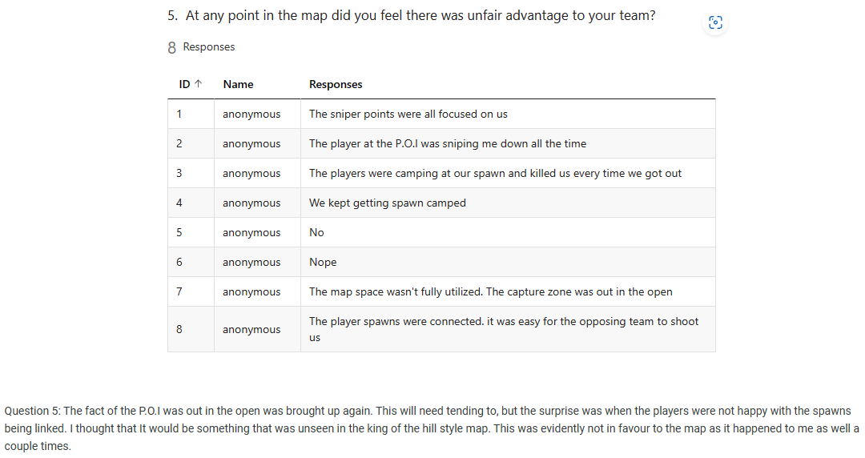 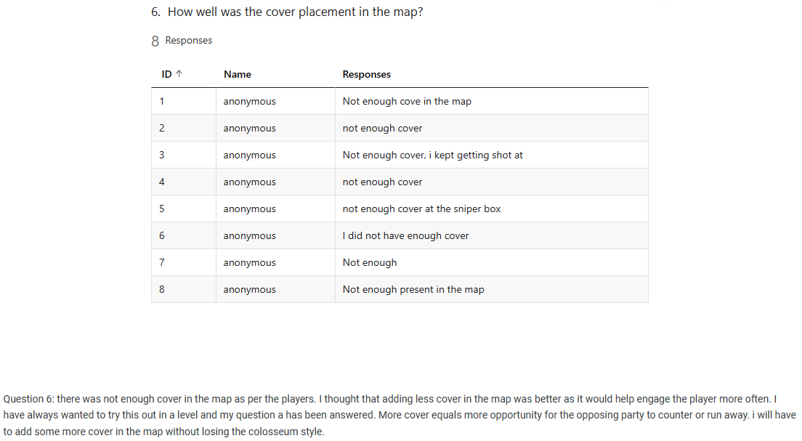

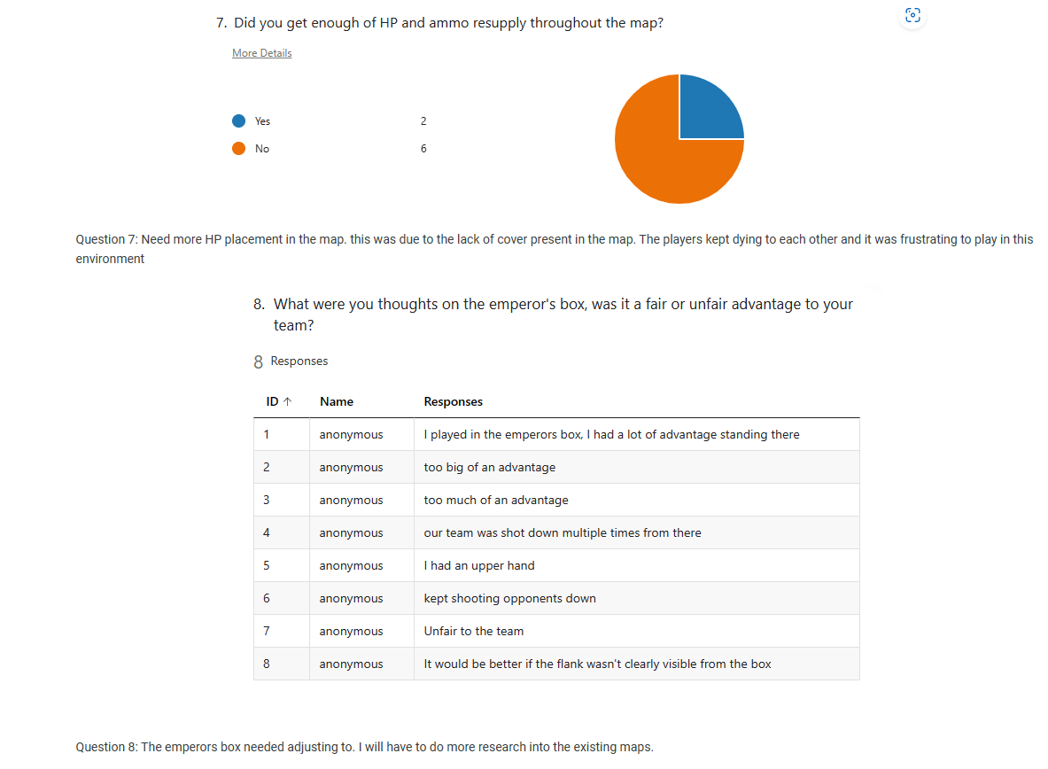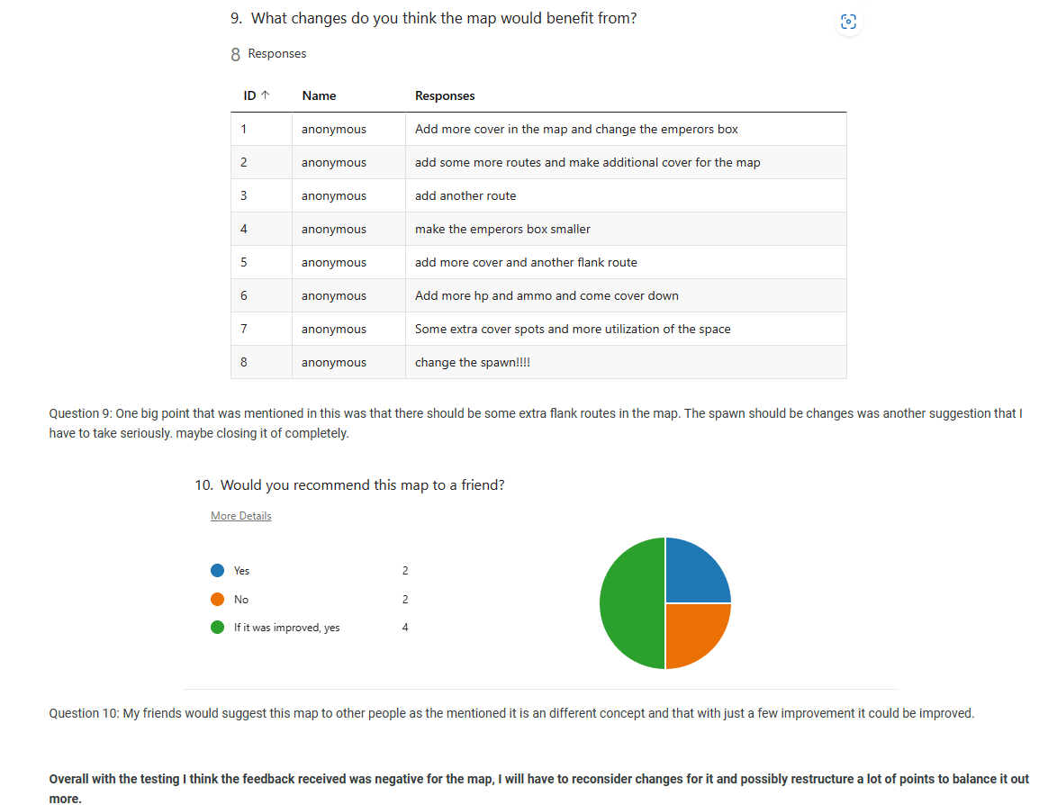

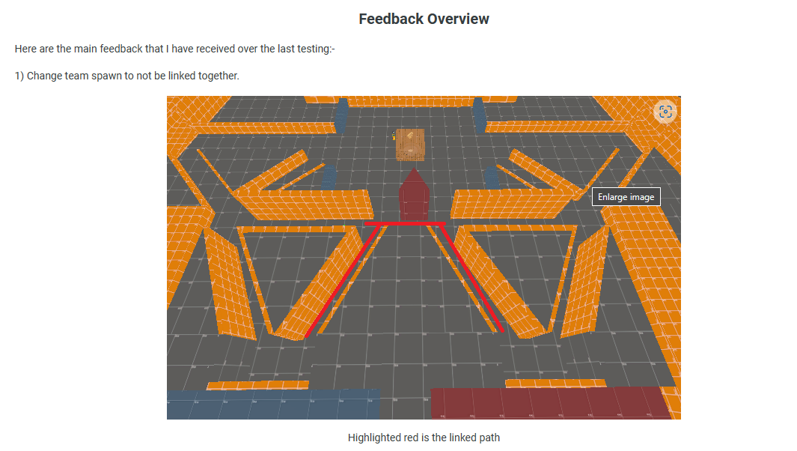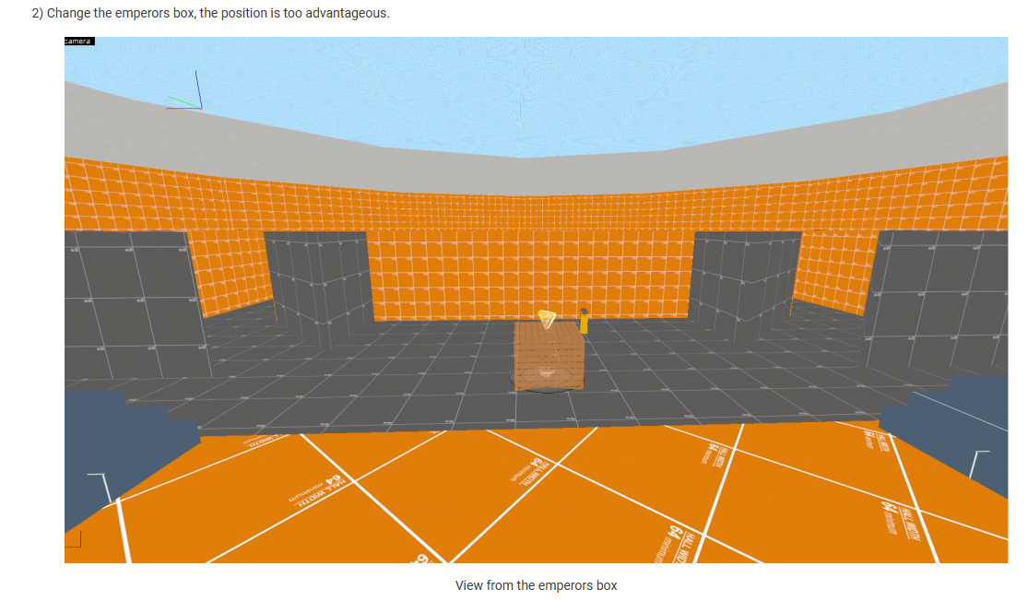

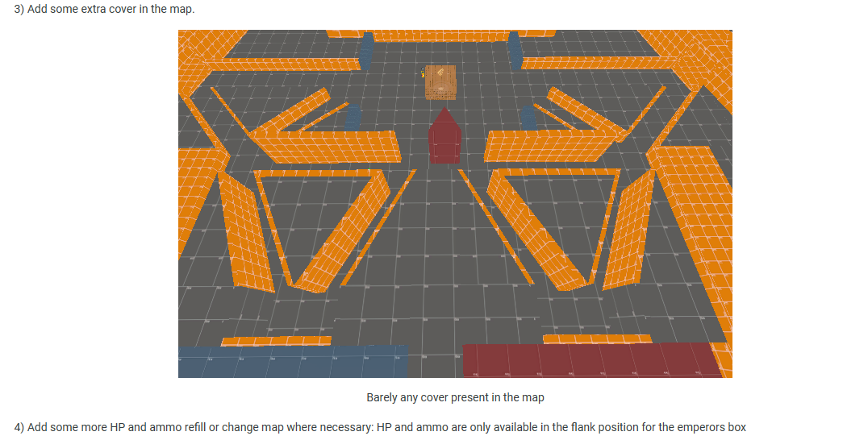

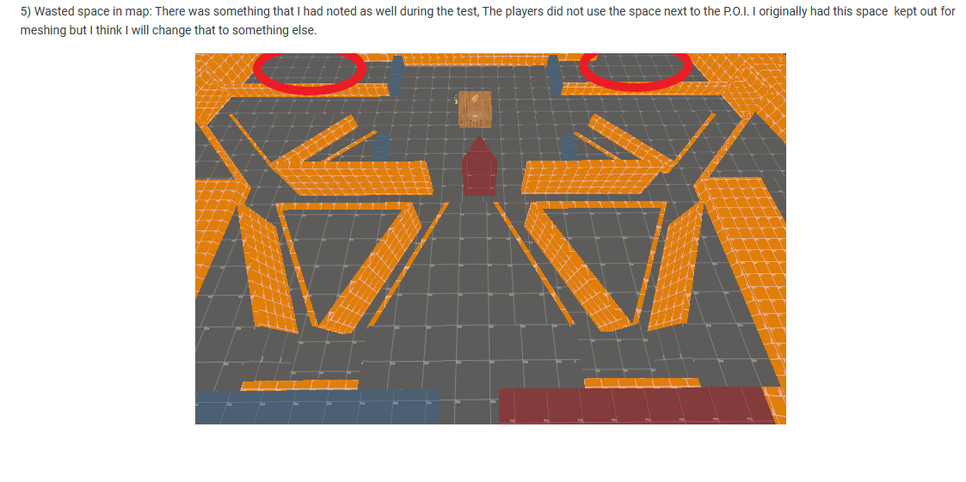

## Mitigation Strategy

I will have to do research on how the levels are built as it would be my first-time using a hammer engine. I would also have to do my research on how roman colosseums are built. To mitigate the issue with the emperor’s box there should be multiple points of entry to the emperor’s box, and I also must conduct research on existing maps to check if there are any similar points of interest and how this was balanced.